**Meenakshi Sundararajan Engineering College : Department of Computer Science and Engineering**

**NM1009 - Generative AI for Engineering**

**TRAFFIC SIGN DETECTION USING CNN**

**SAI PRAVIN (311521104306)**

**NM Id: - aut2231150007**

**ARCHITECTURE :**

**INTERNAL GUIDE:**

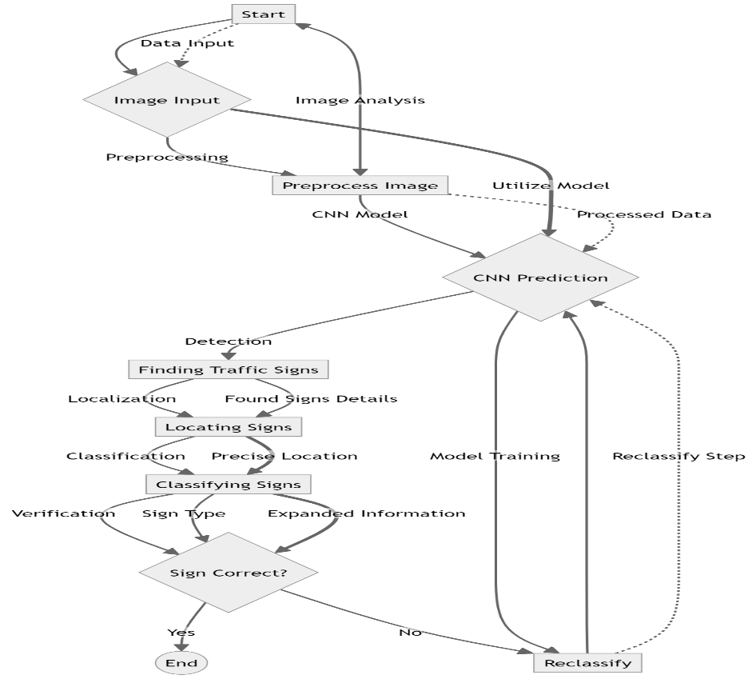Mrs. P. Revathi

**Professor, CSE, MSEC**

**FEATURES:**

1. **Real-Time Traffic Sign Detection**:
   * Utilizes Convolutional Neural Networks (CNNs) to detect and classify traffic signs in real-time from live video streams.
2. **High Accuracy and Robustness**:
   * Achieves high accuracy and robustness in traffic sign detection, capable of handling variations in lighting, weather, and occlusions.